IOT BASED EUTROPHICATION MONITORING SYSTEM

##### A PROJECT REPORT

###### ***Submitted by***

##### TAMILSELVAM P 312317106180

**VENKATESH A 312317106187**

***in partial fulfillment for the award of the degree***

***of***

**BACHELOR OF ENGINEERING**

*in*

# ELECTRONICS AND COMMUNICATION ENGINEERING



ST.JOSEPH’S COLLEGE OF ENGINEERING

CHENNAI 600 119

##### April-2021

**ANNA UNIVERSITY : CHENNAI 600 025**

**BONAFIDE CERTIFICATE**

Certified that this project report “**IOT BASED EUTROPHICATION MONITORING SYSTEM ”** is the bonafide work of **Tamilselvam.P (312317106180) and Venkatesh.A (312317106187)** who carried out the project work under my supervision.

**SIGNATURE SIGNATURE**

Dr.B.Victoria Jancee,M.E, Ph.D., Dr.D.Lakshmi,M.E,Ph.D.,

**HEAD OF THE DEPARTMENT SUPERVISOR**

Associate Professor Associate Professor

Department of Department of

Electronics and Communication Electronics and Communication Engineering Engineering

St.Joseph’s College of St.Joseph’s College of

Engineering Engineering

OMR,Chennai-119. OMR, Chennai-119

**CERTIFICATE OF EVALUATION**

COLLEGE NAME : St. JOSEPH’S COLLEGE OF ENGINEERING

BRANCH : ELECTRONICS AND COMMUNICATION  ENGINEERING

SEMESTER : VIII

|  |  |  |  |
| --- | --- | --- | --- |
| **SI.NO** | **Name** **of** **the students who Have done the Project** | **Title of the project** | **Name of** **the** **Supervisor** **with Designation** |
| 1. | TAMILSELVAM.P  (312317106180) | IOT BASED EUTROPHICATION MONITORING SYSTEM | Dr.D.Lakshmi,M.E,Ph.D.  ASSOCIATE PROFESSOR |
| 2. | VENKATESH.A  (312317106187) |

This report of project work submitted by the above students in partial fulfilment for the award of Bachelor of Engineering in Electronics and Communication Engineering degree in Anna University was evaluated and confirmed to be reports of the work done by the above students.

|  |  |
| --- | --- |
| **INTERNAL EXAMINER** | **EXTERNAL EXAMINER** |

Submitted for UNIVERSITY VIVA VOCE Examination held on 04-08-2021.

**ACKNOWLEDGEMENT**

The contentment and elation that accompany the successful completion of any work would be incomplete without mentioning the people who made it possible.

Words are inadequate in offering our sincere thanks and gratitude to our respected Chairman **Dr. B. BabuManoharan, M.A., M.B.A., Ph.D.**

We express our sincere gratitude to our beloved **Managing Director Mrs. B. Jessie Priya, M.Com., (Commerce) and Director Mr. B. Shashi Sekar, M.Sc.,(Intl. Business)**for their support and encouragement.

We also thank our beloved principal **Dr. Vaddi Seshagiri Rao, M.E,MBA, Ph.D,** for having encouraged us to do our under graduation in Electronics and Communication Engineering in this esteemed college.

We also express our sincere thanks and most heartfelt sense of gratitude to our eminent Head of the Department, **Dr.Victoria Jancee, M.E., Ph. D** for having extended her helping hand at all times.

It is with deep sense of gratitude that we acknowledge our indebtedness to our supervisor **Dr.D.Lakshmi, M.E., Ph.D.** for her expert guidance and connoisseur suggestion.

We thank all staff members of our department, our family members and friends who have been the greatest source of support to us.

**ABSTRACT**

There are 909 freshwater lakes in integrated Kanchipuram district in Tamil Nadu. Most of the lakes are used as a source for freshwater for drinking, agricultural and domestic purposes. Due to rapid urbanization and increase in population, most lakes are polluted as the storm water drains are used as sewage pipelines, which pollute the lakes and induce algal bloom and eutrophication.

Once a lake is eutrophicated, it takes minimum a complete year to regain the old nature of the lake and this happens only if there is sufficient rain in that year and the lake gets replenished with freshwater again. Eutrophication happens at various depths of water at various stages. It starts with the increase in nutrient content of the water at the first stage.

Due to the vast number of lakes in the district, monitoring the water pollutant levels is difficult but if the change in pollution level is noted at an early stage, eutrophication can be avoided.

The objective of the project is to monitor the parameters daily to control the pollution levels. The proposed system is an IOT based eutrophication monitoring system, which will measure the pollution levels using turbidity, Temperature and pH sensors. The sensors collect the respective parameters from the sample. The collected sensor data is sent immediately uploaded to the cloud, directly by the system. This collected data can be viewed and recorded from remote locations.

TABLE OF CONTENTS

**CHAPTER NO. TITLE PAGE NO.**

ABSTRACT v

**LIST OF TABLE viii**

LIST OF FIGURES ix

**1. INTRODUCTION**

1.1 Introduction 1

1.2 An Embedded System 1

1.3 Microcontroller 3

1.4 Summary 5

**2. LITERATURE REVIEW**

2.1 Introduction 6

2.2 Related works 6

2.3 Summary 9

**3. SYSTEM IMPLEMENTATION**

3.1 Introduction 10

3.2 Existing system 10

3.3 Proposed system 11

3.3.1 Block Diagram 11

3.4 Materials Required 11

3.5 Arduino (ATMega328 Microcontroller) 12

3.6 DS18B20 Temperature sensor 14

3.6.1 DS18B20 Pin Description 16

3.6.2 Connections with Arduino 16

3.7 Turbidity Sensor 17

3.7.1 Turbidity sensor working 18

3.7.2 Turbidity sensor Pin Description 19

3.7.3 Turbidity sensor Interface 19

3.8 pH sensor 20

3.8.1 pH Measurement 21

3.8.2 pH sensor Working Principle 21

3.8.3 pH sensor Pin description 23

3.8.4 pH sensor Interface and calibration 24

3.9 LCD Display 26

3.10 ESP8266 – WiFi Module 28

3.10.1 ESP8266 Pin Configuration 29

3.10.2 Interfacing with Arduino 30

3.11 Piezo Buzzer 31

3.11.1 Buzzer Interface 32

3.12 Embedded C 33

3.13 Thingspeak Internet Cloud 34

3.14 The Project setup 34

**4. RESULTS AND ANALYSIS 35**

**5. CONCLUSION AND FUTURE SCOPE 38**

**REFERENCES 39**

**LIST OF TABLES**

**S.No TOPIC PAGE NO**

1.1 Data Obtained from BIS and CPCB guidelines 5

3.1 PIN Description of ESP8266 29

3.2 Pin description of buzzer 32

4.1 Cloud Data downloaded from Thingspeak Server 37

**LIST OF FIGURES**

**S.No TOPIC PAGE NO**

1.1 Block diagram of a typical embedded system 2

3.1 Block Diagram for the Proposed Idea 11

3.2 Arduino UNO 13

3.3 Water Temperature sensor 15

3.4 Temperature sensor interfacing with Arduino 16

3.5 Turbidity sensor 17

3.6 Working of Turbidity sensor 18

3.7 Interface of Turbidity sensor 20

3.8 Pin description of Interface circuit 23

3.9 Ph sensor calibration 24

3.10 Interfacing of pH sensor with Arduino 25

3.11 Pin diagram of LCD 16x2 Display 26

3.12 ESP8266 Module 28

3.13 Interface of ESP8266 30

3.14 Piezo Buzzer  32

3.15 The Project setup 34

4.1 Monitoring of Temperature value 35

4.2 Monitoring of pH value 36

4.2 Monitoring of Turbidity value 36

**CHAPTER 1**

**INTRODUCTION**

* 1. **INTRODUCTION**

Eutrophication is the process in which a water body becomes overly enriched with nutrients, leading to plentiful growth of simple plant life. The excessive growth (or bloom) of algae and plankton in a water body are indicators of this process. Eutrophication is considered to be a serious [environmental concern](https://byjus.com/biology/environmental-issues-solutions/) since it often results in the deterioration of water quality and the depletion of dissolved oxygen in water bodies. Eutrophic waters can eventually become “dead zones” that are incapable of supporting life.

This aspect has become increasingly important with increases in human population and more extensive development of agriculture. Eutrophication now ranks with other major anthropogenic effects such as deforestation, [global warming](https://byjus.com/chemistry/global-warming-due-greenhouse-effect/), depletion of the ozone layer and large scale environmental disturbance in relation to its potentially harmful effect on natural ecosystems. The overconsumption of oxygen leads to hypoxic conditions (conditions in which the availability of oxygen is low) in the water. The hypoxic conditions at the lower levels of the water body lead to the suffocation and eventual death of larger life forms such as fish.

To avoid this we are using Arduino system to constantly monitor the parameters of the water bodies. Combination of sensors are used and their values are stored in cloud to check for possibility of eutrophication.

* 1. **AN EMBEDDED SYSTEM**

An embedded system is a special-purpose computer system designed to perform one or a few dedicated functions, often with real-time computing constraints. It is usually embedded as part of a complete device including hardware and mechanical parts. In contrast, a general-purpose computer, such as a personal computer, can do many different tasks depending on programming. Embedded systems have become very important today as they control many of the common devices we use.



**Fig. 1.1 Block diagram of a typical embedded system**

Since the embedded system is dedicated to specific tasks, design engineers can optimize it, reducing the size and cost of the product, or increasing the reliability and performance. Some embedded systems are mass-produced, benefiting from economies of scale.

Embedded systems provide several functions

* Monitor the environment: embedded systems read data from input sensors. This data is then processed and the results displayed in some format to a user or users
* Control the environment: embedded systems generate and transmit commands for actuators.
* Transform the information: embedded systems transform the data collected in some meaningful way, such as data compression/decompression

Although interaction with the external world via sensors and actuators is an important aspect of embedded systems, these systems also provide functionality specific to their applications. Embedded systems typically execute applications such as control laws, finite state machines, and signal processing algorithms. These systems must also detect and react to faults in both the internal computing environment as well as the surrounding electromechanical systems

* 1. **Microcontroller**

There are many other microcontrollers and microcontroller platforms available for physical computing. Parallax Basic Stamp, Netmedia's BX-24, Phidgets, MIT's Handyboard, and many others offer similar functionality. All of these tools take the messy details of microcontroller programming and wrap it up in an easy-to-use package. Arduino also simplifies the process of working with microcontrollers, but it offers some advantage for teachers, students, and interested amateurs over other systems:

* Inexpensive - Arduino boards are relatively inexpensive compared to other microcontroller platforms. The least expensive version of the Arduino module can be assembled by hand, and even the pre-assembled Arduino modules cost less.
* Cross-platform - The Arduino software runs on Windows, Macintosh OSX, and Linux operating systems. Most microcontroller systems are limited to Windows.
* Simple, clear programming environment - The Arduino programming environment is easy-to-use for beginners, yet flexible enough for advanced users to take advantage of as well. For teachers, it's conveniently based on the Processing programming environment, so students learning to program in that environment will be familiar with the look and feel of Arduino
* Open source and extensible software- The Arduino software is published as open source tools, available for extension by experienced programmers. The language can be expanded through C++ libraries, and people wanting to understand the technical details can make the leap from Arduino to the AVR C programming language on which it's based. Similarly, you can add AVR-C code directly into your Arduino programs if you want to.
* Open source and extensible hardware - The Arduino is based on Atmel's ATMEGA8 and ATMEGA168 microcontrollers. The plans for the modules are published under a Creative Commons license, so experienced circuit designers can make their own version of the module, extending it and improving it. Even relatively inexperienced users can build the breadboard version of the module in order to understand how it works and save money.
* The Arduino Uno is a microcontroller board based on the ATmega328 (datasheet). It has 14 digital input/output pins (of which 6 can be used as PWM outputs), 6 analog inputs, a 16 MHz crystal oscillator, a USB connection, a power jack, an ICSP header, and a reset button. It contains everything needed to support the microcontroller; simply connect it to a computer with a USB cable or power it with a AC-to-DC adapter or battery to get started. The Uno differs from all preceding boards in that it does not use the FTDI USB-to-serial driver chip. Instead, it features the Atmega8U2 programmed as a USB-to-serial converter.
* "Uno" means one in Italian and is named to mark the upcoming release of Arduino 1.0. The Uno and version
* 1.0 will be the reference versions of Arduno, moving forward. The Uno is the latest in a series of USB Arduino boards, and the reference model for the Arduino platform; for a comparison with previous versions.
  1. **SUMMARY**

The Table 1.1 are the desired levels to be maintained obtained by several tests and published by BIS (Bureau of Indian Standards ) and CPCB(Central Polluttion Control Board):

|  |  |  |
| --- | --- | --- |
|  | **Drinking** | **Lakewater** |
| **Nitrate** | 10 ppm | 1-2 ppm |
| **pH** | 6.5 to 8.5 | 6.0 to 9.0 |
| **Turbidity** | <(1 NTU) | 40 NTU |
| **Dissolved Oxygen** | 6.5-8 ppm | > 4 ppm |
| **Ammonia** | 0.5 ppm | 0-1 ppm |

**Table 1.1 Data Obtained from BIS and CPCB guidelines**

The sensor data are collected using Arduino and are uploaded to a cloud using WiFi module. The periodic changes can be easily visualized and monitored by us. This system can be implemented in number of lakes and all the parameters can be monitored from a single location. This will reduce the workload of

PWD and will provide a cost efficient and more dependable system to check

Eutrophication. Any variations from the above given data if found we can proceed with human intervention before it causes further damage.

**CHAPTER 2**

**LITERATURE SURVEY**

**2.1 INTRODUCTION**

A reference of the paper is **Development of IoT for Automated Water Quality Monitoring System** proposed by R. P. N. Budiarti, A. Tjahjono, M. Hariadi and M. H. Purnomo at “2019 International Conference on Computer Science, Information Technology, and Electrical Engineering” (ICOMITEE), Jember, Indonesia*,* 2019 is made to carry out the proposed system in this project.

This paper discussed on using Raspberry pi for IoT data monitoring. The need for water consumption not only for humans but also the other living things as natural supporting elements for continuity of life. Water consumption depends on the availability of water resources like rivers, lakes, and reservoirs. Certainly, water becomes limited natural resources most of them because of water pollutions. It is necessary to manage water quality to fulfil the sustainability of water functions as natural resources, we create an integrated system based on Internet of Things to measuring the water quality by developing environmental water management monitoring system using sensors. The use of raspberry pi as an embedded system will help in the manufacture of detecting sensors device and the use of remote communications technology can help the interaction of sending data between things. The result is the IoT water quality monitoring system can be operated as an automated water monitoring system for surface water and it's real-time online.

**2.2 RELATED WORKS**

A detailed study was carried out to gain maximum insight into the working, efficiency and usage of the various modules and components used in our work.

The papers which were studied are explained below.

**1.IoT Application for Water Quality Monitoring: Nitrates** by L. Hernández-Alpizar, A. Carrasquilla-Batista and L. Sancho-Chavarría at 2020 IEEE 11th Latin American Symposium on Circuits & Systems (LASCAS)*,* San Jose, Costa Rica, 2020. The paper presents a design of an autonomous system for nitrates remote monitoring that uses an adjustable but continuous sampling flow, UV spectroscopy and Internet of Things (IoT) to directly perform and control the system calibration and nitrates quantification and, a strategy to optimize data generation and the monitoring resolution: a conductivity sensor used as a sampling frequency trigger

**2.Preliminary Study of Water Quality Monitoring Based on WSN Technology** by L. Y. Li, H. Jaafar and N. H. Ramli at “2018 International Conference on Computational Approach in Smart Systems Design and Applications” (ICASSDA), Kuching, Malaysia, 2018. Here, a low-cost, large coverage and user friendly water quality monitoring system with multi sensor which is based on Wi-Fi Technology is presented. The process of designing the system involves three main parts which are hardware development, software development and also wireless network process. For hardware development part, different types of sensor will be employed and the sensors will be integrated with microcontroller. As for the software development, a few programming software is integrated for data acquisition, processing and displaying. Finally, for the wireless network process, wireless network module is used to for data transmitting and receiving while website is used to display the obtained data.

**3.Intelligent sensor based monitoring system for underwater** pollution by

S. Premkumardeepak and M. B. M. Krishnan at 2017 International Conference on IoT and Application (ICIOT), Nagapattinam, India, 2017. Here a model is proposed which describes the intelligent sensor based monitoring system which identify and alarms the occurrence of the pollution in the under water. The monitoring system holds the temperature sensors, humidity sensors, pressure sensors wind sensors and chemical sensors with this sensor, the identification of pollution in done through automated and intelligent manner. The efficiency of the system is tested and the results show that the system performs better than the human supervise monitoring process.

**4.An Integrated Cloud-Based Wireless Sensor Network for Monitoring Industrial Wastewater Discharged into Water Sources**  by Yona Zakaria, Kisangiri Michael from School of Computational and Communication Sciences and Engineering, Nelson Mandela African Institution of Science and Technology, Arusha, Tanzania at 2017. This paper presents a prototype of an Integrated Cloud-Based Wireless Sensor Network (WSN) developed to monitor pH, conductivity and dissolved oxygen parameters from wastewater discharged into water sources. the system sends message alert to the responsible organ through GSM/GPRS network and an SMS gateway service implemented by Telerivet mobile messaging platform

**5.Monitoring recent lake level variations on the Tibetan Plateau using CryoSat-2 SARIn mode data** by Liguang Jiang, Karina Nielsen, Ole B. Andersen, Peter Bauer-Gottwein from “Journal of Hydrology”,Volume 544,2017, Pages 109-124, ISSN 0022-1694 in the year January 2017. In this paper , Cryosat-2 SARIn mode data over the period 2010 to 2015 are used to investigate recent lake level variations. The estimated water levels of the 70 largest lakes (> 100 km²) on the TP show that 48 lakes reveal a rising trend (avg. 0.28 ± 0.06 m/yr) while the other 22 show a slightly decreasing trend (avg. -0.10 ± 0.04 m/yr). To compare with the change rates during 2003-2009, ICESat data which cover 42 of the 70 lakes are also used. Factor analysis indicates that driving factors for lake change are variable due to high spatial heterogeneity.

**6.Eutrophication and algal bloom prevention system for reservoirs in Northern China** byWei Li, Zengkai Chai, Weihua Xiao, Chong Gao and Gaoqi Zhang at 2011 International Conference on Remote Sensing, Environment and Transportation Engineering, Nanjing, China, 2011. An eutrophication control and algal bloom prevention system is outlined in this paper which based on the nature environment of the research waterbody and the eutrophied process control experiences. Eutrophication Control System was held which involved Eutrophication Control Subsystem, Monitoring Subsystem and Algal Bloom Prevention Subsystem. The risk water temperature is confirmed as 18°C and 25°C.

**7.The lake water bloom intelligent prediction method and water quality remote monitoring system** by X. Wang et al*.*, at 2010 Sixth International Conference on Natural Computation, Yantai, China, 2010. Here water bloom prediction method based on grey-BP neural network is proposed and a system on water environmental remote monitoring and water bloom early warning based on GPRS wireless communication technology is built, which can obtain the automatic real-time monitoring information for the change of water quality and occurrence of water bloom, then provide a kind of efficient and practical system for water environment control.

**2.3 SUMMARY**

These reference papers have been studied to carry out our project was summarized in this chapter. In this chapter, we have given a brief about the previous works done in this project and about the works that have been motivation to develop the proposed ideaa . In the forthcoming chapter, The modeling of this system and the components used in designing the project will be discussed in depth

**CHAPTER 3**

**SYSTEM IMPLEMENTATION**

**3.1 INTRODUCTION**

Based on the study of above papers and some research into this particular topic we have developed our system. Here few basic parameters such as pH , Temperature and turbidity of the lake is considered. Other parameters such as nitrite level and dissolved oxygen can also be considered to check for the possibility of eutrophication. Since this is only a prototype of the system only few

Parameters are taken into account. The appropriate sensors are connected to a Arduino microcontroller . The whole system is powered by a power source.

All the values are constantly updated in a cloud server by using WiFi module. In our system ThingSpeak is used which is an IoT analytic platform service. Our own page is created with personal username and password and all those values will be plotted based on given requirements.

**3.2 EXISTING SYSTEM**

* There are several such water monitoring systems in use, but it requires a PWD team to visit the lake and sensors will be used to measure the data. But the frequency of monitoring will be very low.
* Hence an immediate action cannot be taken with inadequate and old information.This will surely increase the risk of eutrophication.
* Due to the vast number of lakes in the district, monitoring the water pollutant levels is difficult. But if the change in pollution level is noted at an early stage, eutrophication can be avoided.

**3.3 PROPOSED SYSTEM**

* The proposed system is an IOT based eutrophication monitoring system, which will measure the pollution levels using turbidity, PH, conductivity, and gas sensors. The system will be made to float on the water surface and contains the electronic systems on it.
* The collected sensor data is sent immediately uploaded to the cloud, directly by the system. The Thingspeak cloud is used to view and store the collected data.
* A warning will be produced when the desired levels are found inappropriate.

**3.3.1 BLOCK DIAGRAM**

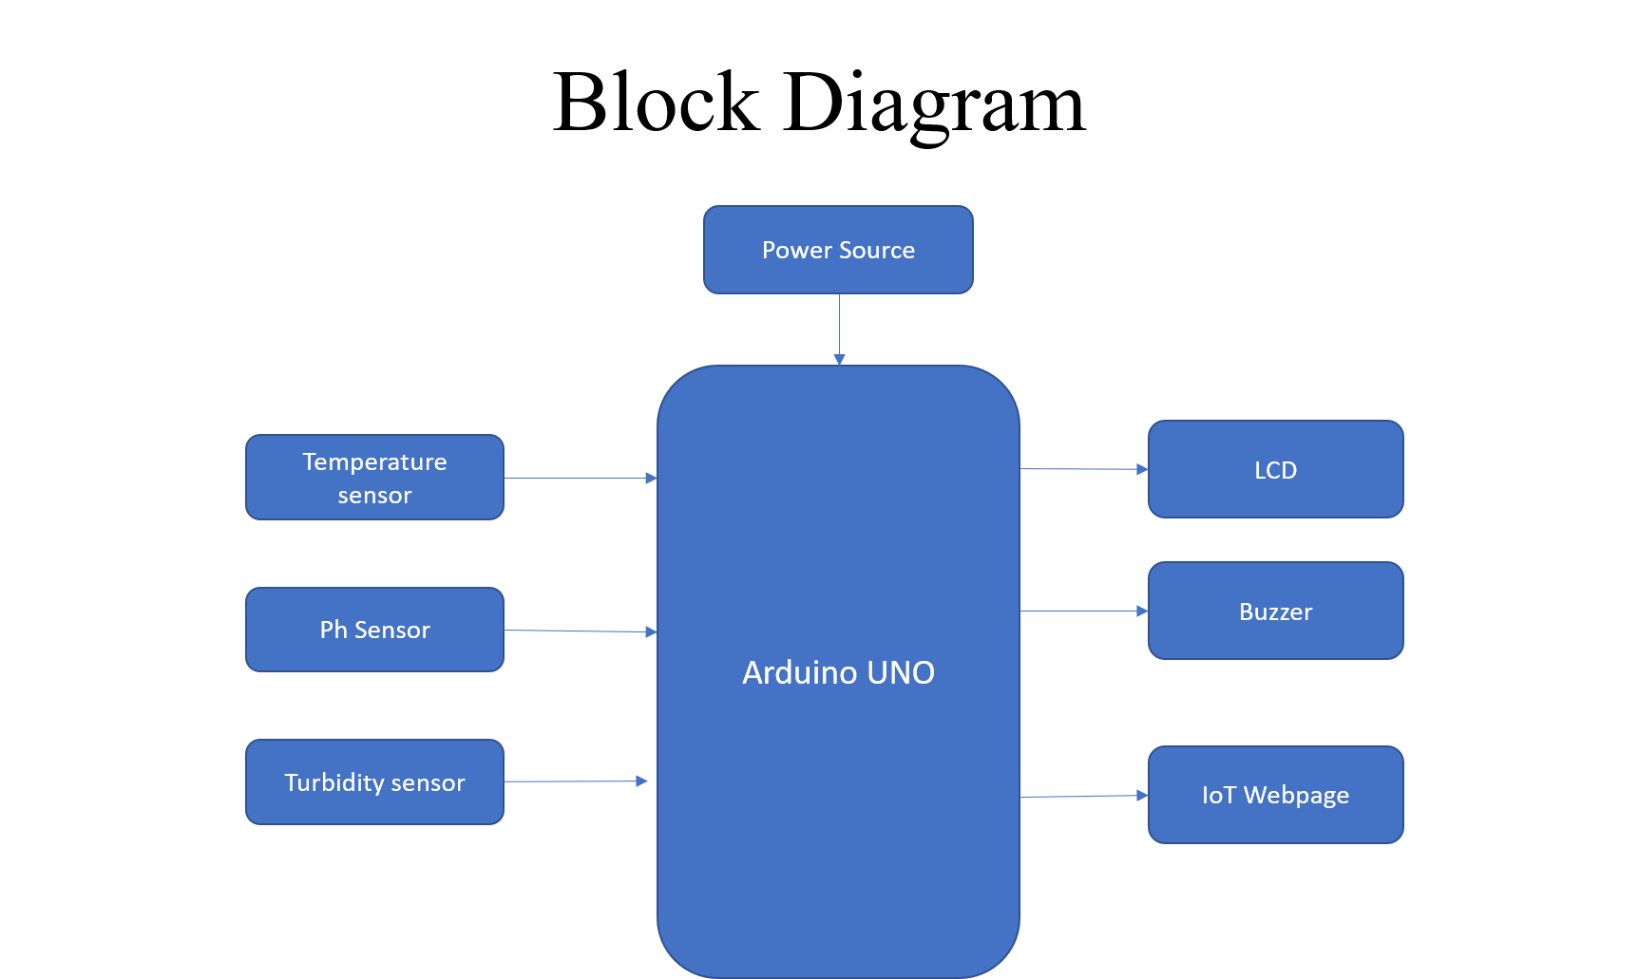

**Fig. 3.1 Block Diagram for the Proposed Idea**

**3.4 MATERIALS REQUIRED**

**HARDWARE:**

1. ARDUINO (ATMega328) MICROCONTROLLER
2. Battery
3. DS18B20 Temperature Sensor
4. Turbidity Sensor
5. pH Sensor
6. LCD Display
7. ESP8266 – WiFi Module
8. Piezo Buzzer

**SOFTWARE :**

**1.** Embedded C

**2.** ThingSpeak

**3.****5 ARDUINO (ATMega328) MICROCONTROLLERS**

Arduino is a tool for making computers that can sense and control more of the physical world than your desktop computer. It's an open-source physical computing platform based on a simple microcontroller board, and a development environment for writing software for the board.

Arduino can be used to develop interactive objects, taking inputs from a variety of switches or sensors, and controlling a variety of lights, motors, and other physical outputs. Arduino projects can be stand-alone, or they can communicate with software running on your computer (e.g. Flash, Processing, MaxMSP.) The boards can be assembled by hand or purchased preassembled; the open-source IDE can be downloaded for free.

The Arduino programming language is an implementation of Wiring, a similar physical computing platform, which is based on the Processing multimedia programming environment.

Each of the 14 digital pins on the Uno can be used as an input or output, using pinMode(), digitalWrite(), and digitalRead() functions. They operate at 5 volts. Each pin can provide or receive a maximum of 40 mA and has an internal pull-up resistor (disconnected by default) of 20-50 kOhms. In addition, some pins have specialized functions:

**Fig. 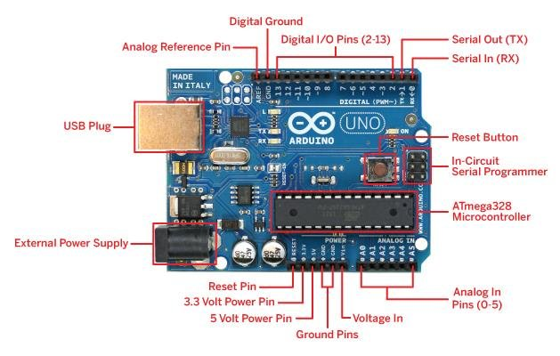3.2 Arduino UNO**

* Serial: 0 (RX) and 1 (TX). Used to receive (RX) and transmit (TX) TTL serial data. These pins are connected to the corresponding pins of the ATmega8U2 USB-to-TTL Serial chip .
* External Interrupts: 2 and 3. These pins can be configured to trigger an interrupt on a low value, a rising or falling edge, or a change in value. See the attachInterrupt() function for details.
* PWM: 3, 5, 6, 9, 10, and 11. Provide 8-bit PWM output with the analogWrite() function.
* SPI: 10 (SS), 11 (MOSI), 12 (MISO), 13 (SCK). These pins support SPI communication, which, although provided by the underlying hardware, is not currently included in the Arduino language.
* LED: 13. There is a built-in LED connected to digital pin 13. When the pin is HIGH value, the LED is on, when the pin is LOW, it's off.
* The Uno has 6 analog inputs, each of which provide 10 bits of resolution (i.e. 1024 different values). By default they measure from ground to 5 volts, though is it possible to change the upper end of their range using the AREF pin and the analogReference() function. Additionally, some pins have specialized functionality:
* I2C: 4 (SDA) and 5 (SCL). Support I2C (TWI) communication using the Wire library.

**3.6 DS18B20 Temperature Sensor**

The digital temperature like DS18B20 follows single wire protocol and it can be used to measure temperature in the range of -67oF to +257oF or -55oC to +125oC with +-5% accuracy. The range of received data from the 1-wire can range from 9-bit to 12-bit. Because, this sensor follows the single wire protocol, and the controlling of this can be done through an only pin of Microcontroller. This is an advanced level protocol, where each sensor can be set with a 64-bit serial code which aids to control numerous sensors using a single pin of the microcontroller.

The DS18B20 is one type of temperature sensor and it supplies 9-bit to 12-bit readings of temperature. The applications of the DS18B20 temperature sensor include industrial systems, consumer products, systems which are sensitive thermally, thermostatic controls, and thermometers.

### Specifications

The specifications of this sensor include the following.

* This sensor is a programmable and digital temperature sensor
* The range of power supply is 3.0V – 5.5V
* Fahrenheit equal s to -67°F to +257°F
* The accuracy of this sensor is ±0.5°C

**Fig. 3.3 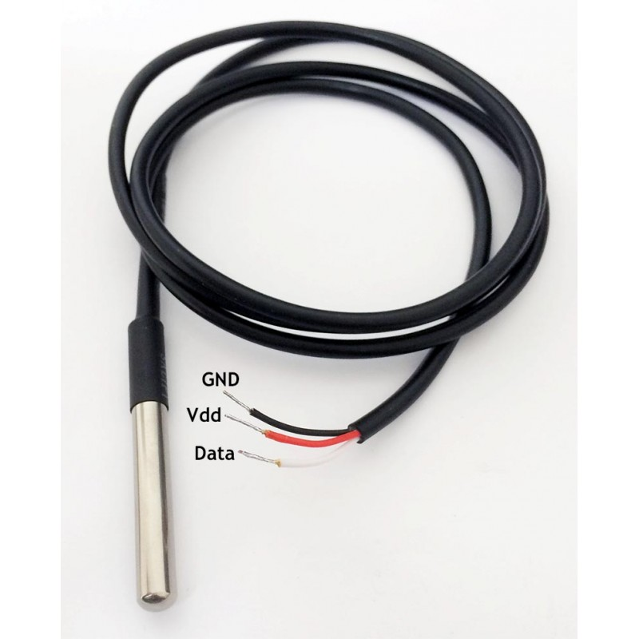Water Temperature sensor**

* The o/p resolution will range from 9-bit to 12-bit
* It changes the 12-bit temperature to digital word within 750 ms time
* This sensor can be power-driven from the data line
* Alarm options are programmable
* The multiplexing can be enabled by Unique 64-bit address
* The temperature can be calculated from -55°C to +125°C.
* These are obtainable like SOP, To-92, and also as a waterproof sensor

### Working Principle

The working principle of this DS18B20 temperature sensor is like a temperature sensor. The resolution of this sensor ranges from 9-bits to 12-bits. The resulting temperature information can be stored within the 2-byte register in the sensor, and after that, this sensor returns to its inactive state.

If the sensor is power-driven by an exterior power supply, then the master can provide read time slots next to the Convert T command. The sensor will react by supplying 0 though the temperature change is in the improvement and reacts by supplying 1 though the temperature change is done.

### **3.6.1 DS18B20 Temperature Sensor Pin Description**

The DS18B20 Sensor consists of three pins namely: VDD, DQ and GND.

**VDD:** This is the power supply pin. It must be grounded when parasite power mode is used (more about this later).

**DQ:** This is the Data Input/Output Pin. It is an open-drain pin and must pulled HIGH. It provides the power in parasite power mode.

**GND:** This is the Ground Pin.

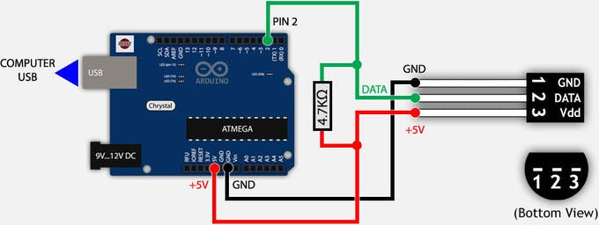**3.6.2 Connections with Arduino**

**Fig. 3.4 Temperature sensor Interfacing with Arduino**

Connect the VDD and GND of the sensor to +5V and GND and connect the DQ Pin of the Sensor to any one of the Digital I/O Pin (it is connected to any one of Digital I/O Pins). The DQ pin is pulled HIGH using a 4.7KΩ resistor.

**3.****7 TURBIDITY SENSOR**

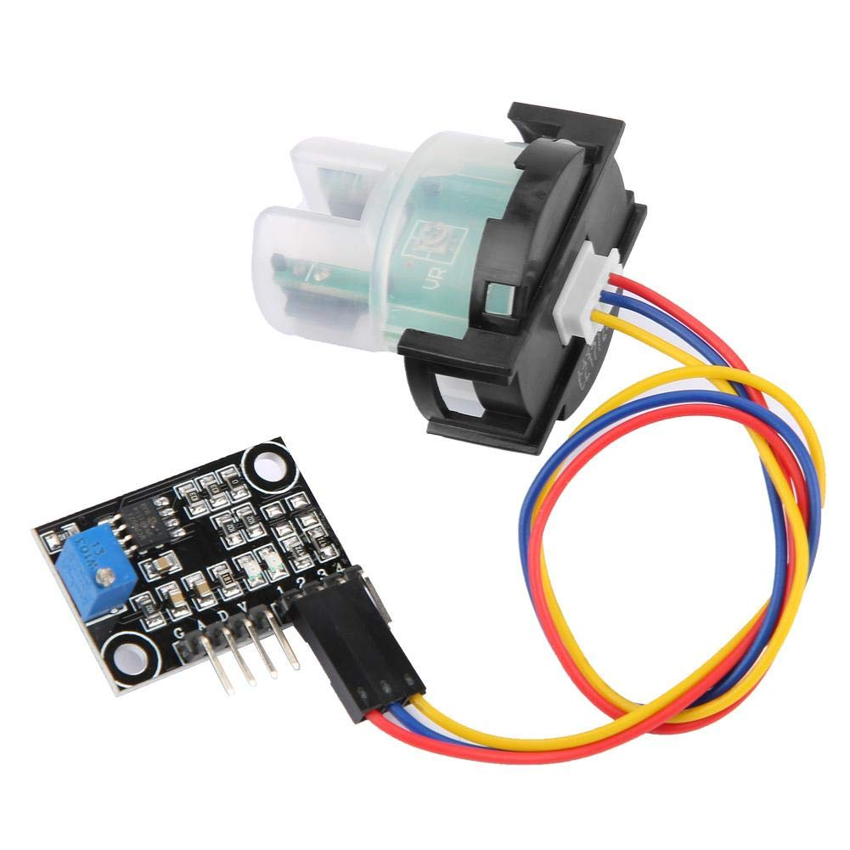Turbidity, the measure of suspended solids in liquids, is utilized as a measure of water quality and can be leveraged as a way for processors to slash waste, improve sustainability and control consumables. Turbidity Meters are engineered to detect the instant a liquid media reaches a pre-defined specification. Some potential applications of Turbidity Meters include

**Fig. 3.5 Turbidity sensor**

* Phase separation of products (for example whey – cream – milk)
* Phase changes product-to-product, product-to-water and water-to-cleaning agent
* CIP-return line (monitoring of pre-rinse water)
* Yeast harvest in breweries
* Quality control
* Leak detection of filter and gaskets

### **3.7.1 Turbidity sensor Working**

With the use of LED light sources, turbidity meters determine the level of particulate matter in water or other fluids. Anderson-Negele, our turbidity partner, defines turbidity as “the phenomenon where by a specific portion of a light beam passing through a liquid medium is reflected by undissolved particles. The sensor measures the light that is reflected by these particles to determine their concentration in the liquid.” For example, purified water would have nearly zero undissolved particles, while ice cream mix has a high concentration.

An infrared diode irradiates infrared light into the media. Particles in the media reflect the irradiated light which is detected by the receiver diode (backscatter principle). The electronics calculate the relative turbidity of the media according to the received signal.The four-beam turbidity meter is specifically designed to meet the requirements of the fluid food and beverage industries. Sanitary by design, Anderson-Negele turbidity meters meet the highest expectations of accuracy, durability, and cleanability.

### 

### **Fig. 3.6 Working of Turbidity sensor**

For high turbidity applications typically found in dairy processing, the ITM-51 Turbidity Meter proves to be a cost-effective insertion sensor for:

* optimizing final flush
* product changeover
* phase transition
* CIP pre rinse control

When low turbidity measurement is needed, the ITM-4 4-beam Turbidity Sensor provides the needed resolution for (COW) water reuse, chill media monitoring and other high purity applications.

**3.7.2 Turbidity Sensor Pin Description**

**Vcc :** This is the power supply pin. This is connected to 5V PIN of Arduino.

**D:** This is an Analog output Pin which is connected to Analog PIN of the Arduino.

**GND:** This is the Ground Pin.

**3.7.3 Turbidity sensor Interface**

The Turbidity sensor is connected to an amplifier module. The Respective pins of the amplifier module is interfaced with the Arduino through the 3 pins. The data Pin gives an analog output which then can be converted to respective TDU value by means the formula

The Figure shows the interface of Turbidity to an amplifier circuit, and its connections to Arduino.

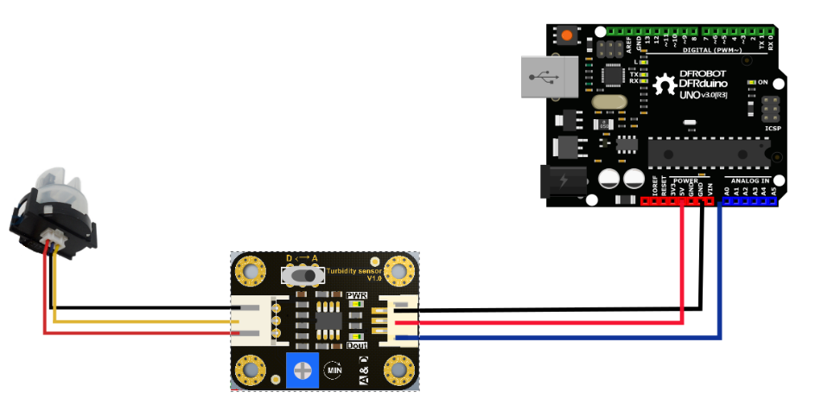

**Fig. 3.7 Interface of Turbidity sensor**

**3.8 PH sensor:**

* A pH meter is a precise instrument that weighs the hydrogen-ion movement in water-based suspensions, showing its acidity or alkalinity expressed as pH.
* It is also called a “potentiometric pH meter” because it measures the variation in electrical potential between a pH electrode and a reference electrode.
* The variation in electrical potential links to the acidity or pH of the suspension.
* This meter is used for experimentation, quality control, etc.
* The word pH is acquired from “p,” the scientific figure for negative logarithm, and “H,” the chemical symbol for Hydrogen.
* pH is a unit of measure that expresses the level of acidity or alkalinity of a suspension. It is graded on a range of 0 to 14. pH = -log[H+]

## **3.8.1 pH Measurement:**

The pH rate of a material is directly linked to the degree of the hydrogen ion [H+] and the hydroxyl ion [OH-] concentrations.

The quantitative data rendered via the pH meter shows the ratio of the movement of an acid or base in terms of hydrogen ion activity.

* If the H+ density is higher than OH-, the substance is acidic; i.e., the pH amount is less than 7.
* If the OH- intensity is higher than H+, the substance is basic, including a pH value higher than 7.
* If identical quantities of H+ and OH- ions are present, the substance is neutral, with a pH of 7.

Free hydrogen and hydroxyl ions possess both Acids and bases. The connection between hydrogen ions and hydroxyl ions in a supplied suspension is fixed for a provided set of circumstances, either one can be resolved by recognizing the other.

## **3.8.2 pH sensor Working Principle**

* A pH meter is made of a few vital components such as Measuring Electrode, Reference Electrode, Temperature Sensor.
* The pH Meter estimates the voltage of an electrochemical cell and based upon the Temperature Sensor defines the pH of a suspension.
* Most of the pH meters contain Combination Electrodes, in which the electrodes and the Temperature Sensor are fabricated within a single frame.
* The algebraic total of the potentials of the Measuring Electrode, Reference Electrode, and the Liquid Junction is known as the overall potential or the voltage.
* The Reference Electrode contains a neutral solution such as Potassium Chloride solution with a fixed concentration. It gives a stable voltage.
* On the opposite, the potential of the Measuring Electrode depends totally upon the pH of the suspension.
* The potential variation (voltage) between a glass membrane of Measuring Electrode and a Reference Electrode which is immersed in the Sample Liquid to be examined is estimated.
* When the two Electrodes are immersed into the Sample Suspension, the ion-exchange process transpires wherein some of the Hydrogen ions flow towards the outside surface of the Measuring Electrode and displace some of the metal ions within it.
* Likewise, some of the metal ions migrate from the Glass Electrode toward the Sample Suspension. The responsiveness of the Reference Electrode potential to variation in pH is negligible or it is unaffected by variations in pH and therefore produces a stable voltage.
* on-exchange processes additionally takes place on the interior surface of the Glass Electrode from the sample suspension.
* This generates a potential variation (Hydrogen- ion activity) among them. The Liquid Junction potential is normally minute and almost constant which essentially depends on the intensity of the ions in the sample suspension.
* Every three potentials are summed up and ranked by High Impedance Voltmeter.
* The potential voltage generated beyond the Glass Electrode membrane is temperature-dependent, by a temperature coefficient of around 0.3% per °C.
* The pH Meters hold provisions to improve the pH Measures as the temperature changes and it is termed as Automatic Temperature Compensation (ATC).
* The output of the Impedance Voltmeter is Voltage studies and it possesses to be calibrated to prepare precise pH Measurement.
* Calibration is performed by immersing the Measuring Electrode into Buffer Liquid of known pH which assists in understanding millivolt reading as pH measurement of the Sample Suspension at the delivered temperature.

**3.8.3 pH sensor pin description**

The pH sensor consists of a pH probe and an Interface circuit as shown below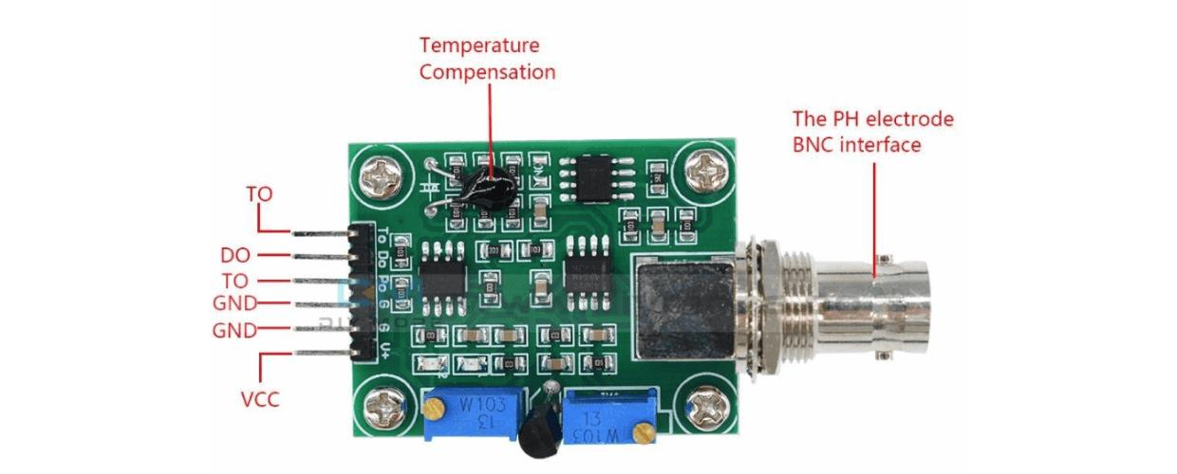

**Fig. 3.8 Pin description of Interface circuit**

Vcc : 3.3V to 5.5V Po : Analog voltage Output To:Temperatute output

GND :Ground Do : 3.3V Output

It has two LEDs which work as the Power Indicator, a pH sensor, a BNC connector. This board is also known as the sensor interface circuit.

This pH Sensor Kit has an on-board voltage regulator chip due to which it can be easily powered up using 3.3 to 5.5Vdc. Due to this wide range of input voltages it can be used with 5V and 3.3V compatible controller boards like Arduino, ESP32, and ESP8266 etc.

The pH Sensor interface circuit is also provided with 6 male headers which are clearly labelled as V+, this is where we connect the 5V from the Arduino. The next two pins are the ground pins, you can connect any of these two pins with the Ground pin of the Arduino.

Po is the Analog output pin, which should be connected with the analog pin of the Arduino. Do is the 3.3V DC output pin. The last pin is the To which is the temperature output.Out of these 6 pins we will only use 3 pins; V+, G, and Po.

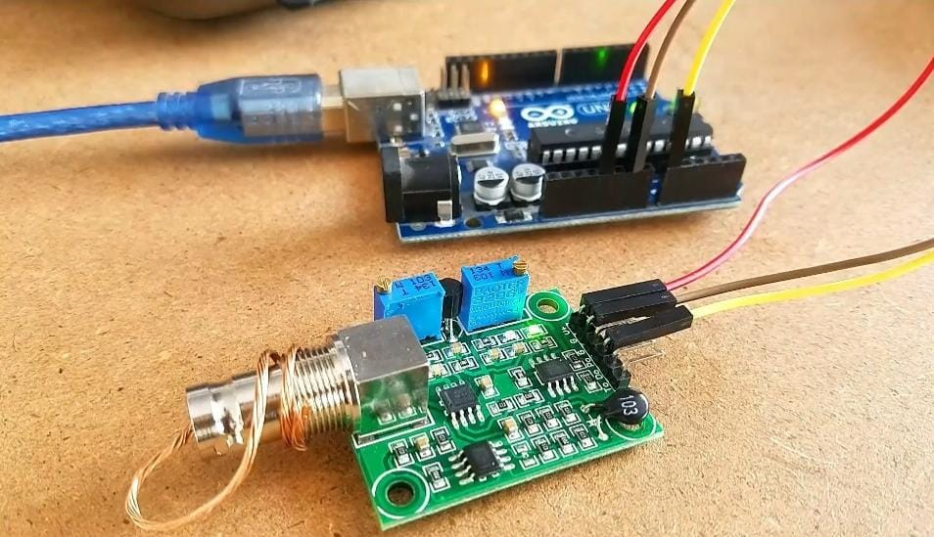**3.8.4 pH sensor Interface and calibration**

**Fig. 3.9 Ph sensor calibration**

To calibrate the sensor a wire is used to short the external part and the centre of the probe connector. This causes a 2.5 volts tension on the Po analog output pin. So the external part of the BNC connector is connected with the centre of the BNC probe connector.

The V+ pin is connected with the Arduino’s 5v. The ground pin of the interface circuit is connected with the ground pin of the Arduino, and finally the analog output pin Po is connected with the A0 pin of the Arduino. The test code is uploaded to the Arduino UNO for calibration.

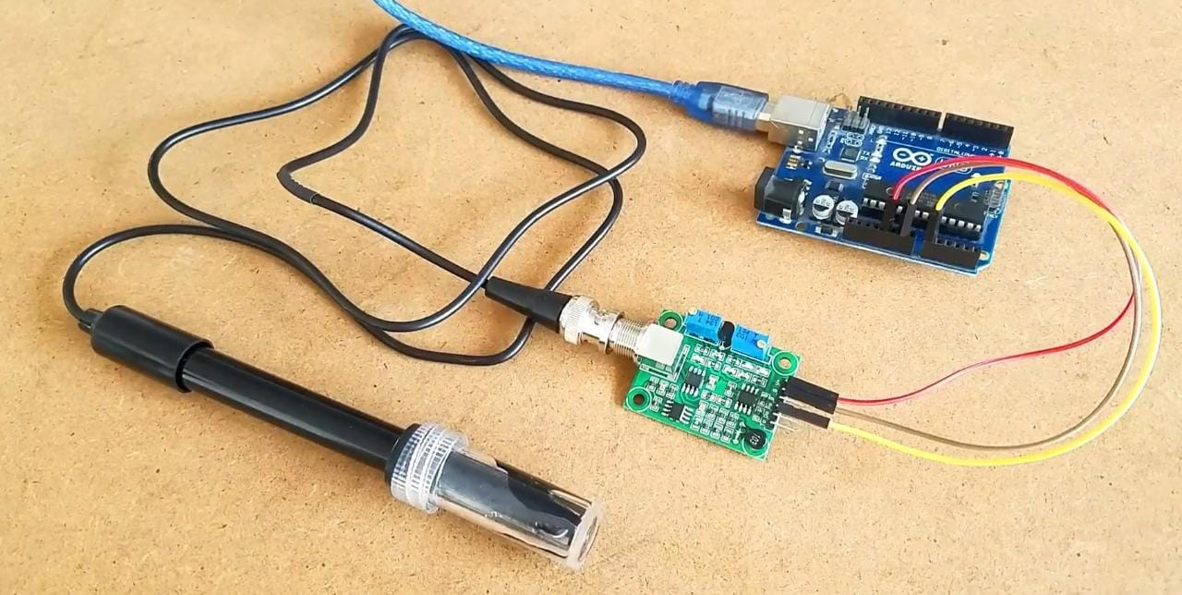If the value on Serial monitor is other than 2.50 then the trimmer is used to adjust this value. The pH value is from 0 to 14. A pH of 7 means 2.5 Volts. So the value must be set to 2.5 volts using the trimmer. The pH Sensor is now calibrated.

**Fig. 3.10 Interfacing of pH sensor with Arduino**

Same connections are used for the interface and the pH electrode is connected to the BNC Connector.

**3.9 LCD DISPLAY**

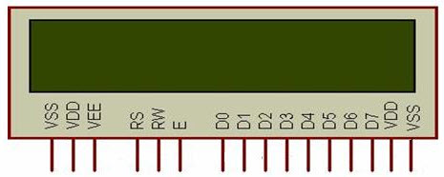Liquid crystal displays (LCDs) have materials which combine the properties of both liquids and crystals. An LCD consists of two glass panels, with the liquid crystal material sandwiched in between them. The inner surface of the glass plates are coated with transparent electrodes which define the character, symbols or patterns to be displayed polymeric layers are present in between the electrodes and the liquid crystal, which makes the liquid crystal molecules to maintain a defined orientation angle. **Fig 3.5** shows the basic Pin diagram of LCD displays.

**Fig. 3.11 Pin diagram of LCD 16x2 Display**

**D0-D7:** Pin number 7-14 are data bus lines that are used to send data from Arduino which you want to display on LCD. With these 8 data lines, data can be transferred either in an 8-bit format or in a 4-bit format. In a 4-bit format, only upper four bits (D4-D7) are used to send data from Arduino to LCD. The full byte is transmitted in two successive transmissions. A 4-bit format is used to save GPIO pins of Arduino. Because fewer GPIO pins of Arduino will be required to transfer data.

**Contrast Select (VEE):** Pin3 will connect with power and ground through 3 pin potentiometers. It will help to control the contrast of PIXELS according to the 16X2 LCD light. 10K ohm variable resistor is connected with the VEE pin to adjust light contrast. Variable resistor one side is connected with 5 volts and the other side is connected with ground. The third terminal is connected with the VEE pin.

**RS**: This pin is known as a register select pin. It helps to toggle the command/data register.

**R/W:** The signal on Pin5 will decide whether it is going to read from LCD or write on it.

**EN:** Enable pin will help to transfer the instruction from the data pins and another command pin to the LCD. It act as permission to internal registers.

**VSS:** It’s a ground pin for common grounds.

**VDD**: The power pin will use for voltage input to the 16X2 LCD.

When the LCD is in the off state, light rays are rotated by the two polarizer and the liquid crystal, such that the light rays come out of the LCD without any orientation, and hence the LCD appears transparent. When sufficient voltage is applied to the electrodes, the liquid crystal molecules would be aligned in a specific direction. The light rays passing through the LCD would be rotated by the polarizer’s, which would result in activating / highlighting the desired characters. The power supply should be of +5V, with maximum allowable transients of 10mv. To achieve a better / suitable contrast for the display, the voltage (VL) at pin 3 should be adjusted properly.

LCD module must be operated under the relative condition of 40°C and 50% relative humidity. Lower Temperature Cancun Retardation of the Blinking speed of the display, while higher temperature makes the overall display discolor. When Temperature gets to be within the normal limits, the display will be normal. Polarization degradation, bubble generation or polarizer peel- off may occur with high temperature and humidity. Contact with water or oil over a long period of time may cause deformation or color fading of the display. Condensation on the terminals can cause electro-chemical reaction disrupting the terminal circuit. When the power supply is given to the module, with the pin 3 (VL) connected to ground, all the pixels of a character gets activated in the following manner.

#### **3.10 ESP8266 - WiFi Module**

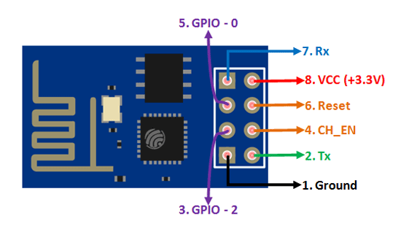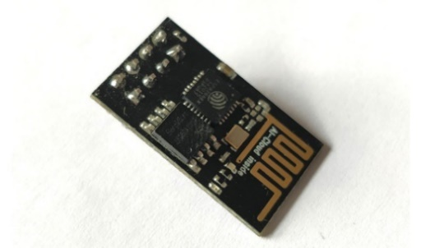

### **Fig. 3.12 Esp8266 Module**

### ESP8266-01 Features

* Low cost, compact and powerful Wi-Fi Module
* Power Supply: +3.3V only
* Current Consumption: 100mA
* I/O Voltage:  3.6V (max)
* I/O source current: 12mA (max)
* Built-in low power 32-bit MCU @ 80MHz
* 512kB Flash Memory
* Can be used as Station or Access Point or both combined
* Supports Deep sleep (<10uA)
* Supports serial communication hence compatible with many development platform like Arduino
* Can be programmed using Arduino IDE or AT-commands or Lua Script

There are so many methods and IDEs available to with ESP modules, but the most commonly used on is the Arduino IDE. The description of the same is discussed below.

The **ESP8266 module** works with 3.3V only, anything more than 3.7V would kill the module hence be cautions with the circuits. The best way to program an **ESP-01**is by using the FTDI board that supports 3.3V programming. No other board must be used. For the power source the Arduino board is used which can give safe power output of 3.3V. One commonly problem that with ESP-01 is the powering up problem of the board. The module is a bit power hungry while programming and hence one can power it with a 3.3V pin on Arduino or just use a potential divider.

### **Applications**

* IOT Projects
* Access Point Portals
* Wireless Data logging
* Smart Home Automation
* Learn basics of networking
* Portable Electronics
* Smart bulbs and Sockets
  + 1. **ESP8266 Pin Configuration**

|  |  |  |  |  |
| --- | --- | --- | --- | --- |
| **Pin Number** | **Pin Name** | **Alternate Name** | **Normally used for** | **Alternate purpose** |
| 1 | **Ground** | - | Connected to the ground of the circuit | - |
| 2 | **TX** | GPIO – 1 | Connected to Rx pin of programmer/uC  to upload program | Can act as a General purpose Input/output pin when not used as TX |
| 3 | **GPIO-2** | - | General purpose Input/output pin | - |
| 4 | **CH_EN** | - | Chip Enable – Active high | - |
| 5 | **GPIO – 0** | Flash | General purpose Input/output pin | Takes module into serial programming when held low during start up |
| 6 | **Reset** | - | Resets the module | - |
| 7 | **RX** | GPIO – 3 | General purpose Input/output pin | Can act as a General purpose Input/output pin when not used as RX |
| 8 | **Vcc** | - | Connect to +3.3V only |  |
|  |  |  |  |  |

**Table 3.1 PIN Description of ESP8266**

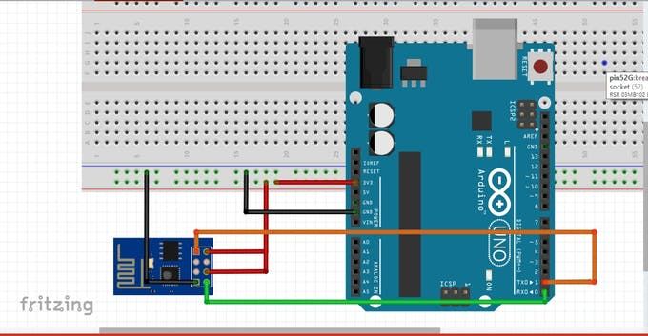**3.10.2 Interfacing With Arduino**

**Fig. 3.13 Interface of ESP8266**

**ESP8266*:-------------- >*Arduino*:***

*GND ----------------------------- GND*

GPIO-2 -------------------------- Not connected (open)

GPIO-0 -------------------------- Not connected (open)

RXD ------------------------------TX

TXD ------------------------------ RX

CHPD ---------------------------- 3.3V

RST -------------------------------Not connected (open)

VCC -------------------------- 3.3V

The connections are made as above after configuring the ESP8266 in the receiving mode.

**3.11 Piezo buzzer**

Piezo buzzeris an electronic device commonly used to produce sound. Light weight, simple construction and low price make it usable in various applications like car/truck reversing indicator, computers, call bells etc. Piezo buzzer is based on the inverse principle of piezo electricity discovered in 1880 by Jacques and Pierre Curie. It is the phenomena of generating electricity when mechanical pressure is applied to certain materials and the vice versa is also true. Such materials are called piezo electric materials. Piezo electric materials are either naturally available or manmade. Piezoceramic is class of manmade material, which poses piezo electric effect and is widely used to make disc, the heart of piezo buzzer. When subjected to an alternating electric field they stretch or compress, in accordance with the frequency of the signal thereby producing sound.

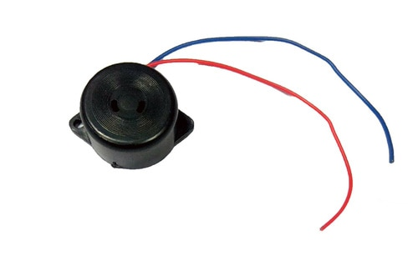

**Fig. 3.14 Piezo Buzzer**

The above image shows a very commonly used piezo buzzer also called piezo transducer operating at DC voltage. Encapsulated in a cylindrical plastic coating, it has a hole on the top face for sound to propagate. A yellow metallic disc which plays an important role in the producing sound can be seen through the hole.

**3.11.1 Buzzer Interface**

|  |  |  |
| --- | --- | --- |
| **Pin Number** | **Pin Name** | **Description** |
| 1 | Positive | Identified by (+) symbol or longer terminal lead. Can be  Powered by 6V DC |
| 2 | Negative | Identified by short terminal lead. Typically connected to the ground of the circuit |

**Table 3.2 Pin description of buzzer**

The positive terminal of the Buzzer is connected to one of the digital Pins of the Arduino (D0 – D13) and when the necessary conditions as mentioned in Table 1.1 is met the Buzzer is turned on by supplying a 5V through the digital pin of the Arduino.

**3.12 EMBEDDED C**

* Embedded C Programming is the soul of the processor functioning inside each and every embedded system we come across in our daily life, such as mobile phone, washing machine, and digital camera.
* Each processor is associated with an embedded software. The first and foremost thing is the embedded software that decides functioning of the embedded system.
* Embedded C language is most frequently used to program the micro controller.
* Looking around, we find ourselves to be surrounded by various types of embedded systems.
* Be it a digital camera or a mobile phone or a washing machine, all of them has some kind of processor functioning inside it. Associated with each processor is the embedded software.
* If hardware forms the body of an embedded system, embedded processor acts as the brain, and embedded software forms its soul.
* It is the embedded software which primarily governs the functioning of embedded systems.
* During infancy years of micro processor based systems, programs were developed using assemblers and fused into the EPROMs.
* There used to be no mechanism to find what the program was doing. LEDs, switches, etc. were used to check correct execution of the program

**3.13 Thingspeak Internet Cloud**

ThingSpeak is an [open-source](https://en.wikipedia.org/wiki/Open-source_software) [Internet of Things](https://en.wikipedia.org/wiki/Internet_of_Things) (IoT) application and [API](https://en.wikipedia.org/wiki/API) to store and retrieve data from things using the [HTTP](https://en.wikipedia.org/wiki/HTTP) and MQTT protocol over the Internet or via a Local Area Network. ThingSpeak enables the creation of sensor logging applications, location tracking applications, and a social network of things with status updates. ThingSpeak was originally launched by ioBridge in 2010 as a service in support of IoT applications.

ThingSpeak has integrated support from the numerical computing software [MATLAB](https://en.wikipedia.org/wiki/MATLAB) from [MathWorks](https://en.wikipedia.org/wiki/MathWorks), allowing ThingSpeak users to analyze and visualize uploaded data using Matlab without requiring the purchase of a Matlab license from Mathworks.

**3.14 The Project setup**

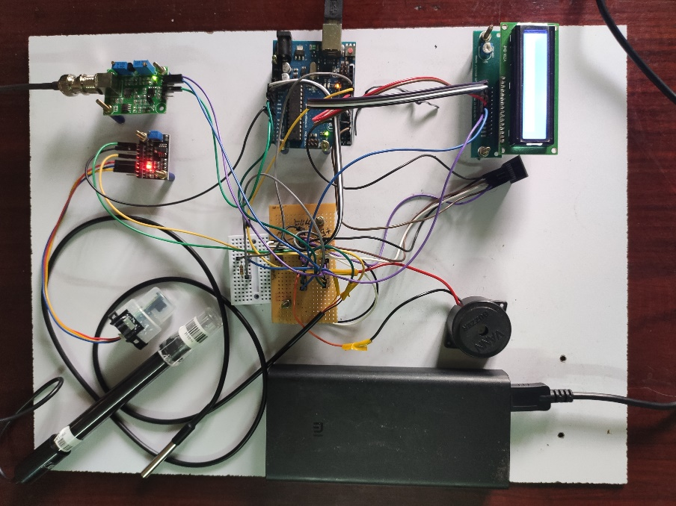Interfacing all the sensors and module to the Arduino UNO and powering up using battery , the final Project setup is shown in the Fig. 3.15

**Fig.3.15 The Project setup**

**CHAPTER 4**

**RESULTS AND ANALYSIS**

In our proposed system three sensors are connected (Temperature, pH, and Turbidity) to the Arduino Uno. These three sensor measures of Temperature, pH, and Turbidity parameters of the water when they dipped in lake or pond.

**a. Measurement of Water Temperature using temperature sensor**

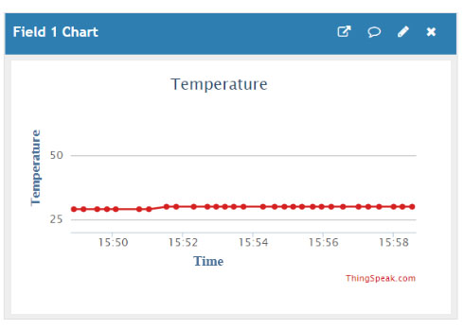The above figure shows how sensor measuring the water temperature in the range from -50°C to 125°C. Basically water temperature is classified into cold, normal and hot based on its temperature. If the temperature is in the range from -55°C to 20°C is considered as cold water, from 21°C to 39°C is considered as normal water and from 40°C to 125°C is treated as hot water.

**Fig. 4.1 Monitoring of Temperature value**

**b. Measurement of pH value of water using pH sensor**

The above figure shows how sensor measuring pH value of the water that ranges between 0 and 14. Based on the pH value, water is classified as acidic, normal and basic. If the value is below 7 it is considered as acidic, above 7 as basic and 7 as normal or good water. In acidic, it is again classified as low acidic (3 to 6) and high acidic (0 to 2). In the same way basic water is also classified into two 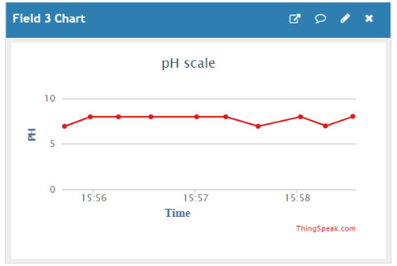types. They are low basic (8 to 10) and high basic (11 to 14).

**Fig. 4.2 Monitoring of pH value**

**c. Measurement of Turbidity of Water using Turbidity sensor**

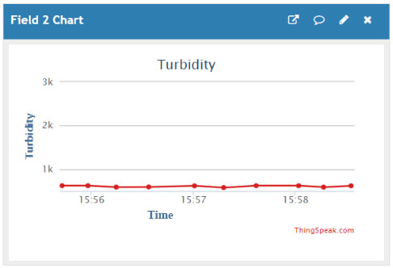The turbidity of water is its clarity. If any mud, slit or sand particles etc. are mixed with the water, its quality varies. According to the water quality norms, normal water ranges from 0 NTU (Nephelometric Turbidity Units) to 10 NTU and also maximum of up to 40 NTU is permissible. If the water goes over 1000 NTU up to 3000 NTU it is classified as turbid or mud mixed water.

**Fig. 4.3 Monitoring of Turbidity value**

The collected data from the Thingspeak server can be recorded for further interpretation and study of a particular Geographical area. The Table 4.1 shows the recorded observations from sample inputs fed to cloud.

|  |  |  |  |  |
| --- | --- | --- | --- | --- |
| created_at | entry_id | Temperature | TDU | pH |
| 2021-03-24 07:55:56 UTC | 821 | 30 | 36.33 | 6.57 |
| 2021-03-24 07:56:24 UTC | 822 | 30 | 65.63 | 6.73 |
| 2021-03-24 07:56:46 UTC | 823 | 30 | 1038.28 | 7.37 |
| 2021-03-24 07:57:03 UTC | 824 | 30 | 1091.02 | 6.79 |
| 2021-03-24 13:55:33 UTC | 825 | 32 | 956.25 | 6.57 |
| 2021-03-24 13:55:52 UTC | 826 | 32 | 956.25 | 7.22 |
| 2021-03-24 13:56:51 UTC | 827 | 32 | 967.97 | 6.57 |
| 2021-03-26 07:23:37 UTC | 828 | 31 | 118.45 | 4.12 |
| 2021-03-26 07:23:53 UTC | 829 | 31 | 111.42 | 4.28 |
| 2021-03-26 07:24:10 UTC | 830 | 31 | 110.84 | 4.32 |
| 2021-03-26 07:25:47 UTC | 831 | 31 | 108.49 | 3.97 |
| 2021-03-26 07:26:03 UTC | 832 | 31 | 112.01 | 4.35 |
| 2021-03-26 07:26:21 UTC | 833 | 31 | 112.59 | 4.5 |
| 2021-03-26 07:26:39 UTC | 834 | 31 | 112.01 | 3.76 |
| 2021-03-26 07:26:54 UTC | 835 | 31 | 110.25 | 3.18 |
| 2021-03-26 07:27:13 UTC | 836 | 31 | 112.59 | 3 |
| 2021-03-26 07:27:33 UTC | 837 | 31 | 114.35 | 2.97 |
| 2021-03-26 07:27:51 UTC | 838 | 31 | 110.84 | 2.58 |
| 2021-03-26 07:28:26 UTC | 839 | 31 | 120.21 | 3.13 |
| 2021-03-26 07:28:44 UTC | 840 | 31 | 122.55 | 3.54 |

**Table 4.1 Cloud Data downloaded from Thingspeak Server**

**CHAPTER 5**

**5.1 CONCLUSION**

This project “IoT Based Eutrophication monitoring system” focused on monitoring the water quality in lake or pond with high performance, real time and accurate. In this proposed system we have measured Temperature, Turbidity and pH values of water with the help of Arduino Uno and various Sensors. These sensor data are stored in open source Internet of Things (IoT) application “ThingSpeak”. By getting the data , the values are calculated and compared it with threshold value. If it is found to be below the threshold, the data are send to ThingSpeak through Wi-Fi Module. If it is below the normal value it will indicate as the value is low by alerting through buzzer.The system can monitor water quality automatically, and it is low in cost and does not require people on duty. So the Eutrophication testing is likely to be more economical, convenient and fast.

**5.2 FUTURE SCOPE**

By using the data from the Table 1.1 it can be interpreted that there are several other factors that concern the Eutrophication levels. Hence A collective data can be obtained from the water resources for each of the parameters. A suitable interpretation software like MATLAB can be used to interpret the obtained data. Several lakes can altogether be monitored from a common station using this wireless network. This can provide knowledge about the various lakes and suitable actions can be identified remotely from a single location.

**REFERENCES**

[1] L. Hernández-Alpizar, A. Carrasquilla-Batista and L. Sancho-Chavarría, "IoT Application for Water Quality Monitoring: Nitrates," 2020 IEEE 11th Latin American Symposium on Circuits & Systems (LASCAS), San Jose, Costa Rica, 2020.

[2] R. P. N. Budiarti, A. Tjahjono, M. Hariadi and M. H. Purnomo, "Development of IoT for Automated Water Quality Monitoring System," *2019 International Conference on Computer Science, Information* *Technology, and Electrical Engineering (ICOMITEE)*, Jember, Indonesia,2019.

[3] J. J. Cancela, X.P. González, M. Vilanova, and J.M. Mirás-Avalos, ‘‘Water management using drones and satellites in agriculture,’’ Water, vol. 11, no. 5, p. 874, Apr. 2019.

[4] Poonam J. Chavan, Manoj Mechkul “IoT Based Water quality Monitoring” IJMTER Journal, Vol 3, pp.746-750, April 2016.

[5] Pradeepkumar M. Manisha J.Praveen Sha R. Proiserin V. Suganya Devi K “The real time monitoring of water quality in IoT Environment” IJIRSET, Vol 5, pp. 4419-4427, March 2016.

[6] Aaina Venkteshwaran, Harsha Menda P. Prof. Priti Bodar “An IoT based system for water quality monitoring” IJRCCE journal, pp. 2510-2515, April 2017.

[7] S.Geeta, S.Goutami “Internet of Things enabled real time water quality monitoring system” Springer Open journal Vol 5, pp. 1-19, 2017.

[8] Jyoti Bhatt, Jignesh Pataliya “IoT based water quality monitoring system” IJIEE journal, Vol 4, pp. 44-48, april 2016.

[9 ] Singh S, Kumar A, Prasad A & Bharadwaj N, “IOT based Water Quality Monitoring System”, IRFIC, (2016).

[10 ] Rao T, Ling Q, Yu B & Ji H, “Estimate the densities of pollutions in water quality monitoring systems based on UV/vis spectrum”, IEEE 26th Conference on Chinese Control and Decision, (2014), pp.2984 -2989 .

[11] S. Sukaridhoto, R. Sudibyo, W. Sarinastiti, R. Dharmawan, A. Sasono, A. Saputro and S. Sasaki, "Design and development of a portable low-cost COTS-based water quality monitoring system," in *2016 International Seminar on Intelligent Technology and Its Applications (ISITIA)*, 2016.

[12] Mithali Borbade, Shruti Danve “Real Time Water Quality monitoring system” IJIRCE journal, Vol 3, pp. 5046-5068, June 2015.

[13] Nikhil Kedia, Water Quality Monitoring for Rural Areas- A Sensor Cloud Based Economical Project, in 1st International Conference on Next Generation Computing Technologies (NGCT-2015) Dehradun, India, 4-5 September 2015. 978-1-4673-6809-4/15/$31.00 ©2015 IEEE

[14] Jayti Bhatt, Jignesh Patoliya, Iot Based Water Quality Monitoring System, IRFIC, 21feb,2016.

[15] Eoin O’Connell, Michael Healy, Sinead O’Keeffe, Thomas Newe, and Elfed Lewis, IEEE sensors journal, vol. 13, no. 7, July 2013, 1530-437x/$31.00 © 2013 IEEE

[16] Nidal Nasser, Asmaa Ali, Lutful Karim, Samir Belhaouari, 978-1-4799- 0792-2/13/$31.00 ©2013 IEEE

[17] Niel Andre cloete, Reza Malekian and Lakshmi Nair, Design of Smart Sensors for Real-Time Water Quality monitoring, ©2016 IEEE conference.